cdffiiifr,e-!
<tcsl-m-"t cErsrtr
-rtu. r" xFr rs )o _{irv3} ^{qri} rooe it
^{qr, qn,} € r( rob-qlr/rooo <{ffn srirftr FF 44ri _{F} oFn, \o'd (ro'o affi _{!r rr} ^{qRi) qi} {nr ri F srs EE€r@ RTd+ra sl1ii. F E i4rq Ei. {trsrrtr4 _{drr!!rr{@!. fiel sturirF]r} ^{q.Ea} .h!, {qr F
r , rfra AElr1I- crct{ s eiff Flr sji{;m _{c{FrA} ^{q1F's} fiF r.rq F _{eRqiffir, r""o ir.{} ^{qffi} --.< '
^{(i)} i.r _{rir} ^{q4?} _{r."! t} erhFl d6G €mE _{<li*} qq ql.i
r I r$r + tu! a sm{dF firA ..rr ft9 _{nl} ^{qft.s,} {l sF{F{rdrr (.) _{\]nr} ^{q{} G:r.qi aqfia ftF @nr _{Bri} ^{qt.} rooo (rooo
^{^6rqtr* qq} a<mn.dftrF;
^{''6{Nir" q{} .l]zsn iEqrinF:
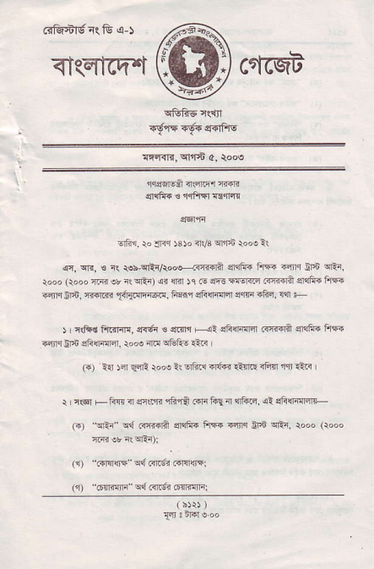
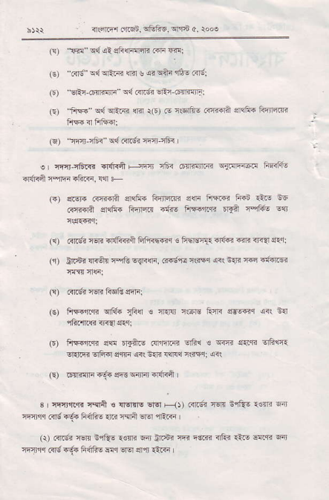
h)Q {rftqr ftqn,qFliE..{'ri c. roo.
(!) lFn ^{q4} si sFnflrsri ..F mi
_{(€)} ^{_Gr6 q{ qrlm} _{lllr} g _{,4i} ^{qai} ffi€ .<ldi
_{F)} ERr _{6rFlt]"} ^{' qq} nrdi sRr-(slnqlrn:
_{i9 fiF} ^{qdqR.{r} {r.r rO) @ rsrfi€ idnra e",1i+ Flicrra _{ftF} ^{qr} FrF?4l
(9 _{!Fr-r6i} ^{', qd.{rg?} eliFr
_{e {rYLrFRr} ^{qr{r<ft} _{Hi$ fi .tn $R} ^{q{mr.4E} r 6Ffto n{i<A:qn +ft<. wt +
(F) eE'" c{tro? s]!Fs iil]l{.trj s!r{ FF@ ffi €'r! EE _{..ri{]A} ^{qla€} Rrrrrr tfie FFftTr _{rqn rrtu} qr
(r) _{cl6r} im nfi<fr hfrrE@q 6 FhErI. €l,16r?E rTq arr: (r) !nF? {l<ft 4qft 6{f<!li, ..drc r!i{q {it t4i @.trnr€"
(!) .<id?rsRffiqni:
(€) _{fiF+riqn} ^{q16} _{$cr} s cl€{, {6F F4. l|s$aq <i! n{
_{(D) flFqrr< s?! rr1fti} (nirr4n _{eltu €} ^{q@} _{s..fr} q6rc{ _{EreriEr} ^{qF.r} sqfr <il n{E !1r{!' r<s{i .er!
(E) _{.rTi{ir{,r'. si3} ^{qjlm} 6|ffi |
s I nf.t f(rr'. rqrii ! _{{Errlg} ^{qq} F{, crdr rer &fu _{1s{rr} ql] i'nfi,r .ng iE! F6tu {lc lqft €re1 {iiF I
(r) .{.6i er! $qfu lw Fr i1.$i ffi rd.n {fti i-F -{..R Fir _{*mq} ^{(!d} ₁₆ h6fr! Er,r Ersr sm rtaa
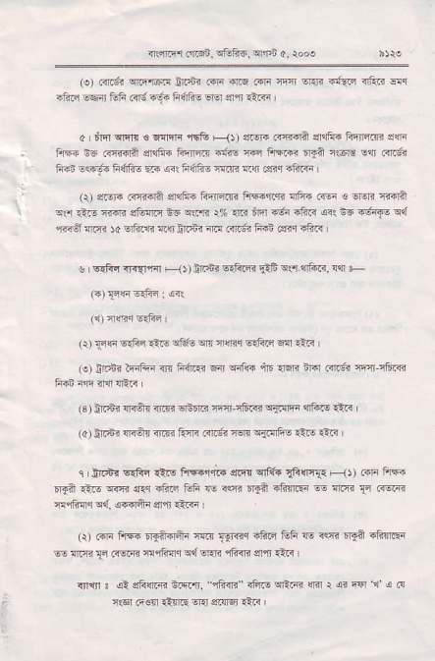
^{q.li@} _{r{qn.} ^{!tuto6, sffrn} 4, roN
_{(e)} ^{qrs. qiEr@r} dc4.i _{.rFl} ^{-4r.s} cri FTJ Er.ri F{..E irF.? dr +FF sqir ffi i<'g -'?'6 lidfiE Ero sr,r' 1t <i I
a I _{tm} ^{qfin} ! rllnr ^{is& F} _{1t} r!r+ cRdn srqf6 FBtrzni sni Fsi E G{dslA 4{Fi i4rra i{r€ nsq ft!@ Fair rloF E".r @.6 Fii es.6€ h6fi- @ 6{ frffi- rd.ri !.$ .:Fq .ftlll
(\) ei! r r.f{{a srqtu{ _{fi'lrEl* ftFr."rj nFF} (T6 € $Eri l?ofi ^{qr} ri.o {tr.li eGflF _{i6} ^{qraR} r% {.r 6lqr 6a -fts ai! nF _{4sr1E} q{ 'rnA nin4 _{)c} ^{qr..s} !.{l trI.6i {r! .{rg? 1i6i lg<q .ftr
$ r 6{fir <F{-,il F-{t _{!r.r"} ^{q{Frr"} _{llF} ^{qs qrft<,} flr r (*)FslrFn _{I} q<1
(q 4q!<r sE€! r
^{(r)} _{{16} ^{q{6c} _{{'nE} ^{qlft} w $4ir _{6rfiF} ^{q{r} €.{ |
^{(o)} Nr airEr nr fift€ Eir s&F {r rlfii nr6l .{c'. nrJ'rft.<
^{(s} ) Gnsr {r<Or 3rR -lnnF wrl r8clr _{rdilrq?} ^{qtus} Ri< ^{(a)} !r.6i lrTft <n!i R{i ^{FR6} _{"i6rn} ^{q{.!rF_o} €! qlri
c , _{ft:nr} ^{q{tu} !\.q FF."r;E _{e.B} ^{q1E} _{1Rffi{{} F--(t .{i FiF !r€ _{€.8} i@ er.r _{rF.r.r eF} 'rE ^{qqrr} 6'S1 4fi{.Er * ^{rrm} _{{i} .-l@ _{nrFrlr} ^{qd} {@rtu $a €Rr
(r) rirr ^{fiF 'r{ffir r,lt{} _{Tgrdr} ilirElih F <w lEA.ftnEr ^{@ aft8} _{F} ..ER _{EffirF} ^{q{} sr:E cfi_iii 4{, €.i I
riri ! _{al aFffi iiR"i.} ^{_"fiin} _{rFi.E} ^{qtm} _{{.r !} ^{qa} tar'1 s@ IlGr e€n €nriE Er{ s.ndl €rr I
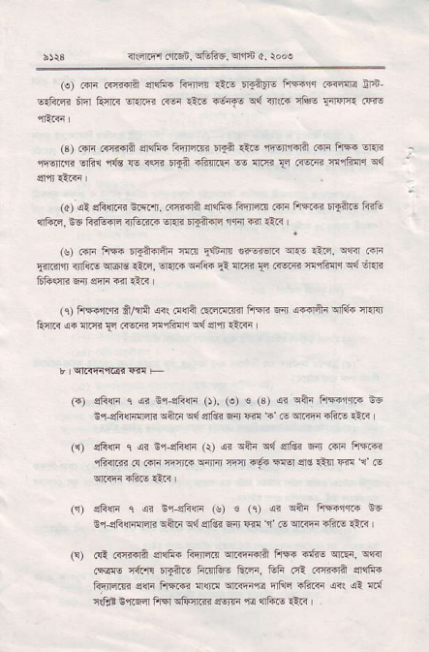
^{qqFr} _{rfl'68} ^{q8fr6, qrfE} _{0.} rooe
(!) m c{dda srqftT F']n4 €.E raallg ftT {5lq .{rr4s ffi ^{q.fii4} nfl Frra om.Fr r.6 €F _{{6{E} ^{q?1} rr{r rl@ t{rar4r .q€
(s) .in a4iir? elqfi_4liirsm Ir€ €s rr!ftrll? .oa fif. l]ar _{n-nrr"} gltu 'ri's :l! r(q; r€ 4Fser * ^{fli4i} _{11 trsrii fliFqr} q{
(a) {l sfrrlm nrR.n. _{Grd4l$} ^{qrt]ftr} FE]E { ...r ftffi rEftE fl3e 11ftr, !E ffi4lq _{<rtu@} ^{q.F} _{.rtil€rr} ^{']fir} {ir rL<
(s) i"F ftF _{rrftflaa} ^{lm} _{EGil3} r6rsrF erF _{ri|q,} ^{qrir} .rF _{Eiri.rr <nliI!} ^{q6ro} _{1ao, €tnR} ^{q41ii} _{!l} ^{!n:R} _{{r} ^{(TsrTr} _{r!'lh{q} ^{qd} Eni Gliffr E n s'lr 6rl drr I
(i) FrF,r.* _{fi/tii} ^{qrr} _{o(ja ccmrm hqt} ^{qn} _{{{€Arr} ^{qrft.} n rq Itftr {i ^{!lr{i} _{{d rl.@ n1fin '} ^{q{} er,i €tri
(r) sFln 1 ^{<r Er,eli4i} _{O).} (e) € (3) _{sa} ^{qiF} FFiqr. i6 _{i'i3fi(lrn]iR} qqlr qd ^{qiti} 6{ m 5 e {tiF.iiF dti
_{sfrlri} ^{q} .sr Er,slirir (r) _{ei} ^{qfti q{} e1|64 6ir cini Fr'*l@ _{iiiR @ ..lr rc} ^{qrFl} rqn lEr FEr sG _{€l]} @ e F
^{qFG} _{c} ^{qi} _{n,i31icli (s) € (c) 4} ^{qqr} FFlfl? nc E%sF{Far _{rr} qA1? q{ qrlni ^{q{} _{w 1 .€} ^{qirq? ?ftE} rt<
.q. F{@n s@ _{rirFrn} ^{q..FfrFr} ir @. '@, "q .€{o 4{fir Drafts t@rGE ft4{, _{ffi} ^{(€} .{:r{qi e]{lii _{liq'rffi sffi FrErF{ {{l!l} ^{qiin,rd} _{nftq aftF 6r} ^{qi} ft{ r@ _{Er.Fdr ft{} ^{qftqm} _{e6na} ^{'E} $tuq €.r I
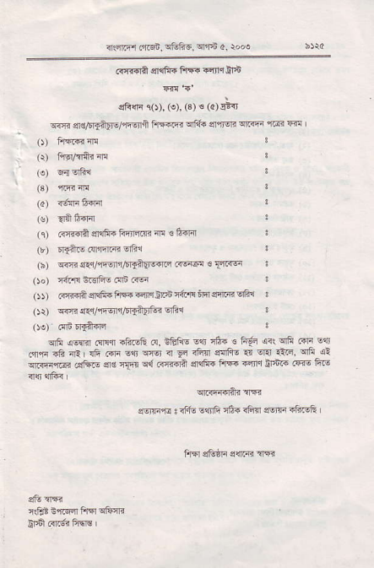
^{qrft'r-} _{..lzEi,} ^{qFh6. qls} o, r'd
@ffa srcfi_. fiFq4fi$6
^{qR{lr} ro). (€). (3) ! (a) E iT
^{gm} 4sffii['-e/,ft3ii hffiqffi _{er'0EE} ^{q.iri} 'Fr R I _{o)} fis.oirr!
(r) nq/riiiar4
_{(o)} q-aqFr
₍₃₎ ^{q.nr} rr!
_{{a)} r6{F6{Fr
(!)
^{"ifr{r4r} (q) .i8i'r$ $&fr. fi'li4na al! € ftdal
(b) ETftE.{*rid vrtu
(b) -@.n{'intqr,5qfu1q{lrd .iE464 € Fr{q
_{Oo)} rtu! terf's .!'r .@
_{ot GTftft} qef6hF@iq$dTaFinqir@qft 3 _{or)} qni.&r/rFql'i/6qitirtu? qal
qfr ^{q@ril} i${qr -ffi G, i&fi ^{oili} _{"h} {i 4fi cri _{E$} ^{qr€r <r} FI
^{qr.orrrai} .gftF _{$6 rllt} ^{q{} Rft{rn
Eqr rA' _{€ fr{E <(} ^{qF} _{..li} €q rGn ffi1t6 ₄ ^{qq} €@, ^{qii} dl enfF FF ^{d4llr} _{ir5F} 6i€ ftE
_{s-rrrn} . rfi! sanfi 164 <fi4 an" EftEE
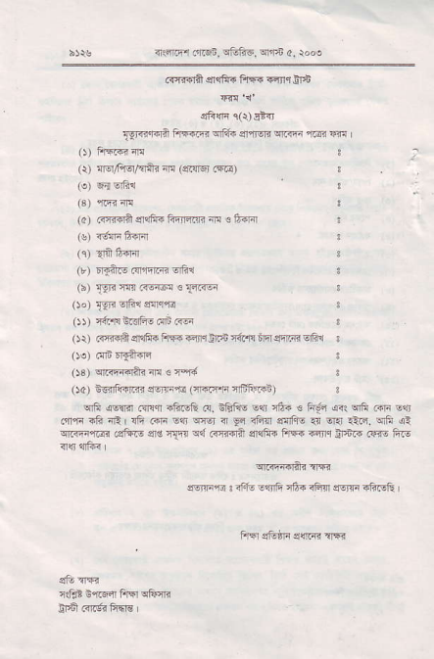
^{q5r.} _{.!iist,} qtrFE ^{q'rt} c, rooo
.firqti c1aii. FiF .!fi Ii6
_{f$-4rqa Fill.m} ^{qlt6 g$r4 rl@} @ rfl |
_{O)} fF|frfi
(r) wtFrq/$iir iI{ (!Er6l.{e)
(s) 6{qtu
(a) _{.re{fl} ^{q]qtui} Finr.q N € fifl
(s) r6F Fsrir
^{(q)} _{{il} li{r-'
_{G)} f$r.e.{r1rR ertu
^{(h)} _{19r?ft.-!@} €T4@
od) _{I9!} Ertu e!er!
_{ot} {4*4 S.E!! ('lb ({F
_{O\)} arFfiqlF ftFqn4ffi {€,Fin€qrFiErft s _{oe)} .rF fdl?jr
_{Os)} ^{q.<@6E{fr} € r'r{
_{Oa) isi'li+lrn crgFq< (n.FF} qffiirD
^{qlfr} ,ae{nr .{r!q sftsE rc, ifiFv sqr _{!6. ! ii6 arl} ^{qfi} .oF E{r atl,lr sli iR | !F cri _{Eq} ^{q46r n} _{9r iBlr} ^{glr8E} .q Era _{till.} ^{qfi} d? ^{qm''@} _{6cfd.€ srs rstr} ^{q,1.rrrT6ln} erqFr FrFlr iqiq 3r5z1' rTtr6 &F
wq{daB nFr
@rF@ € _{a1S'6} ^{q$q} 16. rFrq e!]!i ifiI!& |
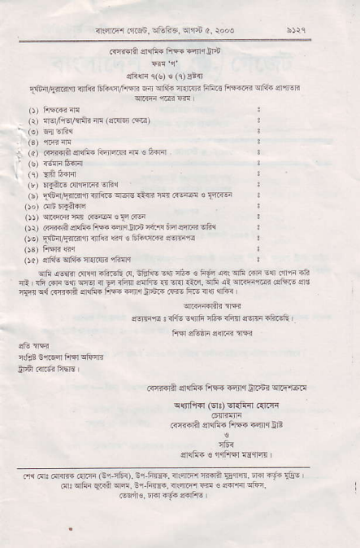
^{q*lriEr} rrFn, _{rtu@.} ^{qfn} a, rooo
_{i!!@A} qdi{fftnrii6
ces (s) ! (r)sr-
_{[f,_4W!F1'} ^{qfd} _{lir6q/Fm} ^{q qili} ft.qt FiiF FF"@qfda arqr
\.],@-
i- @4€{nrfl,@@'
(3) +nm
. 'r ffin4@@]r@4e'q
⁻ (e) .frE@
_{I'j} Es" 4qI@ i-{
,, "iirEnn-i-@jE,Fm.i'rE3{.@
otor"@4@sri@
_{.),} €{st $i'd _{m} ^{c-.} _{{-F 4lr* iq ffi} qfi
_{L)} ,. _{Ed. Arffi} .rf@ 4r e tr @ mm
_{Oa} sfan _{o1+a} ^{.lre} "ia
lrF {qr{ ^{.qFd} _{":6F&} d, _{tEFE ss na. € 6F <{} ^{qE} ffi !t .{r in {i !fi _{.qr} Eq ^{!s {} _{F rfi{} ^{qqFF} ₃ ^{qi} _{rld.} ^{qrh} _{4r} ^{!nm.F} i!F.- s. cFr c,f R{@i dEjii tue @r _{sr6.{} ^{(@} E@ {{t {rF
q@qqtu.m
$!]Fn I d& €qfi nft{ rFi 'rttF ?aF&
Frifiil 4a6i4 EF €nq _{ii.6r} ^{qrF} l6F
^{q{nFial} _{(srt} ^{q{1iir} .{.ri
R{tr6rir sr{ii. FrEi ^{{.rlq} o?
slqli. ! $t5r {drd l
ni Fr. ffi €rF _{Gl} 161. ^{E1 hm. ir|!@r ffia} _{Tgm.} @ ^{.!i} {Es _{o:} ^{q'hi} _{sarn} ^{qF.} €+F@. n'r@ _{@ € ffi} ^{qF} r,
_{@6n€.} !r? f.6 d!fis I

